|  |  |  |  |  |
| --- | --- | --- | --- | --- |
| 1 | 2 | 3 | 4 |  |
| X | y | w | z | f |
| 0 | 0 | 1 | 0 | 0 |
| 0 | 1 | 0 | 0 | 0 |
| 0 | 1 | 1 | 0 | 0 |
| 0 | 1 | 1 | 1 | 0 |
| 1 | 0 | 1 | 0 | 0 |
| 1 | 1 | 1 | 1 | 0 |

|  |  |  |  |  |
| --- | --- | --- | --- | --- |
| 1 | 2 | 3 | 4 |  |
| X | y | w | z | f |
| 0 | 0 | 1 | 0 | 0 |
| 0 | 1 | 0 | 0 | 0 |
| 0 | 1 | 1 | 0 | 0 |
| 1 | 0 | 1 | 0 | 0 |

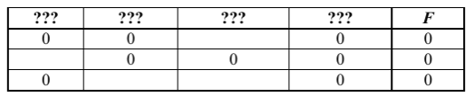w может быть только на 3 месте, тогда y на 1, удаляем 3 строку

|  |  |  |  |  |
| --- | --- | --- | --- | --- |
| 1 | 2 | 3 | 4 |  |
| y | X | w | z | f |
| 0 | 0 | 1 | 0 | 0 |
| 1 | 0 | 0 | 0 | 0 |
| 0 | 1 | 1 | 0 | 0 |

Ответ

|  |  |  |  |
| --- | --- | --- | --- |
| y | x | w | z |

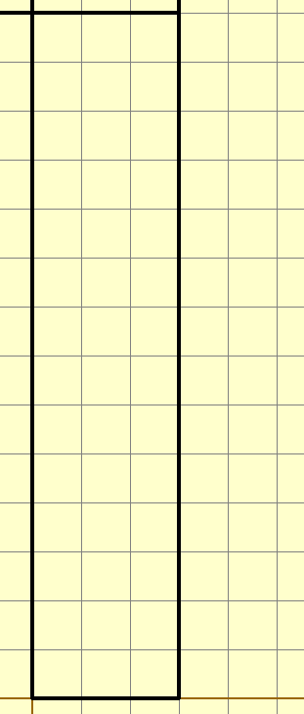26

28 и 8